STUDENT HAND BOOK
BACHELOR OF TECHNOLOGY

SEMESTER-4TH
STUDY SCHEME-2012

DEPARTMENT OF COMPUTER SCIENCE ENGINEERING
ASRA COLLEGE OF ENGINEERING & TECHNOLOGY, BHAWANIGARH

STUDY SCHEME - 2012

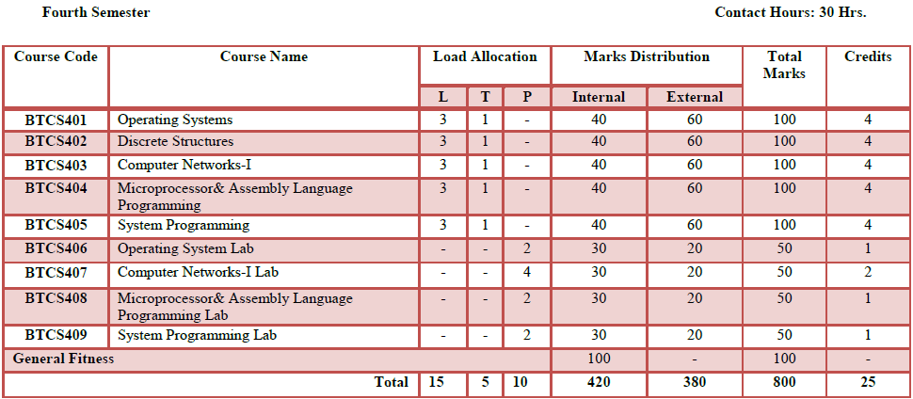

PTU Syllabus -BTCS 401 Operating Systems

L T P
3 1 2

PART-A

1. Introduction to Operating system, Role of Operating System as resource manager, function of kernel and shell, operating system structures, views of an operating system. [5]

2. Process management: CPU scheduling, Scheduling Algorithms, PCB, Process synchronization, Deadlocks, Prevention, Detection and Recovery [5]

3. Memory Management: Overlays, Memory management policies, Fragmentation and its types, Partitioned memory managements, Paging, Segmentation, Need of Virtual memories, Page replacement Algorithms, Concept of Thrashing [8]

PART-B

4. Device Management: I/O system and secondary storage structure, Device management policies, Role of I/O traffic controller, scheduler [5]

5. File Management: File System Architecture, Layered Architecture, Physical and Logical File Systems, Protection and Security: [5]

6. Brief study to multiprocessor and distributed operating systems. [4]

7. Case Studies: LINUX / UNIX Operating System and Windows based operating systems [4]

Suggested Readings/ Books:

1. A Silberschatz and Peter B. Galvin, “Operating System Concepts" Addison” Wesley Publishing Company
2. Dhamdhere, ―Systems Programming & Operating Systems” Tata McGraw Hill
3. Gary Nutt, “Operating Systems Concepts”, Pearson Education Ltd. 3rd Edition
4. Operating System by Madnick Donovan
5. Operating System by Stallings

Assignments-BTCS 401 Operating Systems

Assignment No. 1
- What do you mean by scheduling? Explain with example the Shortest Job First (SJF) scheduling and Round robin scheduling algorithm?

- Explain the difference between Distributed and Multiprocessor operating systems.

- What is an OS? Discuss in detail how the OS can be classified into different categories.

- Consider the following set of processes with the length of CPU burst time given in milliseconds:
  - PROCESS BURST TIME PRIORITY
    - P1 10 3
    - P2 2 3
    - P3 1 1
    - P4 5 2
    - P5 4 4
  - The processes are assumed to be arrived in order P1, P2, P3, P4, and P5.

Explain
  - FCFS (ii) SJF (iii) RR (iv) Priority scheduling.
  - Take a time quantum of 1.
- Give an example of producer-consumer problem, indicating the reasons for inconsistency thatcan arise due to race conditions.
  - Semaphores
- What is CPU scheduling? What is its need? List various scheduling algorithms.
Assignment No.2
- What is deadlock? List and explain four necessary conditions for deadlock to occur? Explaindifferent algorithms for prevention and avoidance of deadlocks.
- Explain the difference between internal fragmentation and external Fragmentation which one occurs in paging system?
- Explain Deadlock Prevention and Avoidance.
- What is virtual memory? What are its various advantages?
- (a)How can you prevent circular waiting situation in a deadlock?
(b)Which is the main limitation of resource allocation graph?
- What do you mean by page-faults? Describe the action taken by theO.S when page fault occurs?
- Explain the difference between internal fragmentation and external fragmentation.
  - Which one occurs in paging system?
- Explain how a deadlock can be represented graphically for two processes and two resources.
  - Discuss the merits/demerits of two ways in which the operating system can recover from adeadlock.
- What is thrashing? How does the system detect thrashing? What can the system do to eliminate the problem?

- What is paging? Explain different paging techniques.
- Explain the concept of segmentation taking suitable examples.

Assignment No.3
- Compare and contrast Public - key cryptography technique with. Conventional cryptographyTechnique.
- Explain the architecture of LINUX Operating System.
- Explain how UNIX has a better policy to handle smaller files than the larger files? Explain how UNIX is booted. Show in node structure in UNIX.
- What do you mean by file management? Explain the various access and Allocation methods of Files in detail.
- Discuss in detail the Data Encryption Standard (DES) algorithm.
- Write short notes on the following:
        - Two-phase locking
        - ‘Wait-die and Wound-wait.
- What do you mean by file management? Explain the various access and Allocation methods of files in detail.
- Explain the Access Matrix in detail?
- Difference b/w Linux and UNIX.

Tutorials- BTCS 401 Operating Systems

Tutorial No 1
- On a system with n CPUs, what is the maximum number of processes that can be in the ready, run and waiting states?
- For each of the following transitions between process-states, indicate whether the transition is possible. If it is possible, give an example of one thing that would cause it.
- Run -> Ready
- Run -> Blocked (Waiting)
- Run -> Terminated
- Blocked -> Run

- For a processes listed in Table, draw a chart illustrating their execution using:
- First-Come-First-Served
- Shortest Job First
- Round Robin (Quantum=2)
- Round Robin (Quantum=1)
Process | Arrival Time | Processing Time
A | 0.000 | 3
B | 1.001 | 6
C | 4.001 | 4
D | 6.001 | 2

- Compare a process and a thread.
- Explain preemptive and non-preemptive scheduling.
- A brief introduction on Memory, Process, Storage and Mass-Storage Management.
- On a system with n CPUs, what is the maximum number of processes that can be in the ready, run & waiting states?
- For the processes liked in table, draw a chart illustrating their execution using Priority Scheduling. A larger priority number has higher priority.
Process | Arrival Time | Burst | Priority
A | 0.000 | 4 | 3
B | 1.0001 | 3 | 4
C | 2.0001 | 3 | 6
D | 3.0001 | 5 | 5
- Preemptive.
- Non preemptive

9. What do you understand by semaphore. How it will be implemented in critical section problem

Tutorial No.2
- Consider the following segment table:
Segment Base Length
0 219 600
1 2300 14
2 90 100
3 1327 580
4 1952 96
What are the physical addresses for the following logical addresses?
(a) 0,430
(b) 1,10
(c) 2,500
(d) 3,400
(e) 4,112
- Under what circumstances do page faults occur? Describe the actions taken by the operating system when a page fault occurs.
- Consider the following page-replacement algorithm on a five point scale from “bad” to perfect according to their page fault rate. Explain why?
a) LRU replacement
(b) FIFO
(c) Optimal

- Why do some systems keep track of the type of a file, while others leave it to the user or simply do not implement multiple file types? Which system is “better”.
- Give an example of an application in which data in a file should be accessed in the following order:
- Sequentially
- Randomly
- Given process resource usage and availability as described in following table, draw the resource allocation graph.
Process | Current allocation |  |  | Outstanding requests |  |  | Resource available
 | R1 | R2 | R3 | R1 | R2 | R3 | R1 | R2 | R3
P1 | 2 | 0 | 0 | 1 | 1 | 0 | 0 | 0 | 0
P2 | 3 | 1 | 0 | 0 | 0 | 0
P3 | 1 | 3 | 0 | 0 | 0 | 1
P4 | 0 | 1 | 1 | 0 | 1 | 0

THEREAFTER, verify
Is this a deadlock state?
- How Deadlock prevention is different from deadlock avoidance?
- What is an unsafe state? Should we call a deadlock state to unsafe state?
- Is it possible to have a deadlock involving only one single process? Explain your answer with an example.
- Consider the traffic deadlock a) show that the four necessary conditions for deadlock indeed held in this example. B) state a simple rule that will avoid deadlock in this system.
- Suppose that a system is in unsafe state, show that it is possible for the processes to complete their execution without entering a deadlock state.
- Consider the following snapshot of a system
 | Allocation | Max | Available
 | A B C D | A B C D | A B C D
P0 | 0 01 2 | 0 0 1 2 | 1 5 2 0
P1 | 1 0 0 0 | 1 7 5 0
P2 | 1 3 5 4 | 2 3 5 6
P3 | 0 6 3 2 | 0 6 5 2
P4 | 0 01 4 | 0 6 5 6
Answer the following questions using Banker’s Algorithm
- What is the contents of Matrix Needed?
- Is this system in a safe state?
- If a request from process P1 arrives for (0 4 2 0), Can the request be granted immediately?
- Why the page is sizes always powers of 2?
- Why is that, on a system with paging, process cannot access memory it doesn’t own? How could the operating system allow access to other memory?
- How are segmentation and paging sometimes combined into one scheme?

Tutorial No.3
- What is a lock-key mechanism? Compare this mechanism with other implementations of Access Matrix.
- The access-control matrix could be used to determine whether a process can switch from, say, domain A to domain B and enjoy the access privileges of domain B. is this approach equivalent to including the access privileges of domain B in those of domain A?
- How does the principle of least privileges aid in the creation of protection systems?
- How can systems that implement the principle of least privileges still have protection failures that lead to security violations?
- What hardware features are needed in a computer system for efficient capability manipulation? Can these be used for memory protection?
- Why do some systems keep track of the type of a file, while others leave it to the user or simply do not implement multiple file types? Which system is “better”.
- Give an example of an application in which data in a file should be accessed in the following order:
- Sequentially
- Randomly
- What problems could occur if a system allowed a file system to be mounted simultaneously at more than one location?
- In what situations would using memory as a RAM disk be more useful than useful than using it as a disk cache?
- Suppose that a disk drive ahs 5000 cylinders, numbered 0 to 4999. The drive is currently serving a request at cylinder 143, and the previous request was at cylinder 125. The queue of pending requests, in FIFO order is,
86, 1470, 913, 1774, 948, 1509, 1022, 1750, 130
Starting from the current head position, what is the total distance (in cylinders) that the disk arm moves to satisfy all the pending requests for each of the following disk-scheduling algorithms?
- FCFS
- SSTF
- SCAN
- LOOK
- C-SCAN
- C-LOOK

Tutorial No 4
- A Password may become known to other users in a variety of ways. Is there a simple method for detecting that such an event has occurred? Explain your answer.
- What is the purpose of using a “salt” along with the user-provided password? Where should the “salt” be stored, and how should it be used?
- Discuss a means by which managers of systems connected to the internet could have designed their systems to limit or eliminate the damage done by a worm. What are the drawbacks of making the change that you suggest?
- What are three advantages of encrypting data stored in the computer system?
- Discuss how the asymmetric encryption algorithm can be used to achieve the following goals:
  - Authentication: the receiver knows that only the sender could have generated the message.
  - Secrecy: only the receiver can decrypt the message.
  - Authentication: only the receiver can decrypt the message, and the receiver knows that only the sender could have generated the message.
- What are the benefits of DFS when compare to a file system in a centralized system.
- What aspect of distributed system would you select for a system running on a totally reliable network?
- Compare and contrast the techniques of caching disk blocks locally, on a client system, and remotely, on a server.

PTU Syllabus- BTCS402 Discrete Structures

L T P
- 1 0

1.Sets, relations and functions: Introduction, Combination of Sets, ordered pairs, proofs of general identities of sets, relations, operations on relations, properties of relations and functions, Hashing Functions, equivalence relations, compatibility relations, partial order relations. [7]

2. Rings and Boolean algebra: Rings, Subrings, morphism of rings ideals and quotient rings. Euclidean domains Integral domains and fields Boolean Algebra direct product morphisms Boolean sub-algebra Boolean Rings Application of Boolean algebra (Logic Implications, Logic Gates, Karnaugh- map) [8]

3. Combinatorial Mathematics: Basic counting principles Permutations and combinations Inclusion and Exclusion Principle Recurrence relations, Generating Function, Application. [7]

4. Monoids and Groups: Groups Semigroups and monoids Cyclic semigraphs and submonoids, Subgroups and Cosets. Congruence relations on semigroups. Morphisms. Normal subgroups. Dihedral groups. [7]

5. Graph Theory: Graph- Directed and undirected, Eulerian chains and cycles, Hamiltonian chains and cycles Trees, Chromatic number Connectivity, Graph coloring, Plane and connected graphs, Isomorphism and Homomorphism. Applications.

Assignments- BTCS402 Discrete Structures

Assignment-I
TOPIC: Theory of Sets, Relations & Inclusion and Exclusion Principle

- If A= {1,2,4,5}, B={a,b,c,f},C={a,5} then (AUC)*B=?
- Prove that if AB, then A*B c B*C
- Prove that (A*B)∩(C*D) = (A∩C)*(B∩D)
- To prove : A*(B∩C) = (A*B)∩(A*C)
- A*(BUC)=(A*B)U(A*C)
- Consider the subsets A={1,7,8},B={1,6,9,10},C={1,9,10}, when U ={1,2_ _ _10} list the
  - Non- empty generated by A,B and C
- Let A={1,2,3,4,5,6}, and let B1= {1,3,5}, B2= {1,2,3} write the maxsets generated by B1 and B2.
- If A and B are two subsets of universal set then A-B =A∩B^{c}
- Prove that AU(B-A)= AUB
- Define union and intersection of two sets A and B
- Describe the set of even integers in set builder notation.

Assignment-2
TOPIC:Monoids& Groups

- Define monoidsand semi-groups.
- Prove that the identity element and inverse element in a group is unique.
- Define Group and Abelian group.
- Consider the group G={1,2,3,4,5,6},under multiplication modulo 7.
  - Find the composition table of G.
  - Prove that G is a group.
  - Find the inverse of 2, 3&1.
- Prove the cancellation law.
- Prove that the congruence relation is equivalence relation.
- Prove that intersection of two subgroups is also a subgroup.
- Let H be a subgroup of G.Then Ha=Hbiff ab⁻¹$∈$ H.
- If H be a subgroup of G.Then HH=H.
- Define Cosets and Cyclic Group.
- State and prove Lagrange’s theorem.
- Prove that every cyclic group has a cyclic subgroup.
- Define Homomorphism and Normal Subgroup.

Assignment-3
TOPIC: Combinatorial Mathematics, Recurrence Relations& Ring Theory

- Define rings, sub rings, Integral domain. Skew Field.
- Prove that every field is an integral domain.
- Prove that finite integral domain is field.
- Define ideals.
- If R be a ring such that x²=x, prove that x+x=0 and x+y=0 then x=y.
- Find how many arrangements can be made with the letters of the word ‘MATHEMATICS’? in how many of them vowles occur together?
- In how many ways can 5 boys and 5 girls be seated at a round table , so that no two girls sit together?
- How many subset of {1,2,--------10}contain at least 7 elements?
- If seven positive integers are chosen two of them will have same remainder ,when divided by 6?
- Find the least no. of cables required to connect 100 computers to 20 printers to guarantee that 20 computers can directly access 20 diff. printers .justify your answers.
- Find the no. of a subset of an S containing n elements.
- A set contains (2n+1) elements. If the no. of subset of this set which contains almost n elements is 8192, find n?
- 36. In how many ways can two integers be selected from the integer 1, 2, 3…..100 so that their difference is exactly seven?
- Solve the following recurrence relation and initial conditions:
- S(k)- 7S(k-1)+ 10S(k-2)=0, S(0)=4, S(1)=17
- S(k)- 10S(k-1)+ 9S(k-2)=0, S(0)=3, S(1)=11.
- Find the generating function of the sequence of the recurrence relation:
a_{n} + 3a_{n-1}=0 with a₀=7.

Assignment-4
Topic: Graph Theory

Define the following terms:
- Graph
- Adjacent Nodes
- Isolated Nodes
- Directed And Undirected Graph
- Mixed Graph
- Self-Loop
- Simple Graph
- Multigraph
- Trivial Graph
- Walk , path, open walk and closed walk
2) Prove that the sum of degrees of the vertices of graph of G is twice the number of edges.
3) The maximum degree of any vertex in a simple graph with n vertices is n-1.
4) Show that the maximum number of edges in graph with n vertices and no multiple edges is n(n-1)/2.
5) What is bipartite graph?
6) What do you understand by chromatic number?
7) Prove that bipartite graph is 2-colouable.
8) State and prove 5-colour theorem
9) State and prove Euler’s formula.
10) Explain Hamiltonian and Eulerian graph
11) What is the minimum number of vertices necessary for a graph with six edges to be planar, witheleven edges?
12) If a graph C has more than two vertices odd degree, then prove that there isno Euler path in G
13) An undirected graph possesses Eulerian path if it is connected and has either zero or two vertices of odd degree. Give suitable example.

Assignment-5
Topic: Boolean Algebra & Trees

- State De-Morgan’s Laws in Boolean algebra.
- Simplify using Boolean and show that

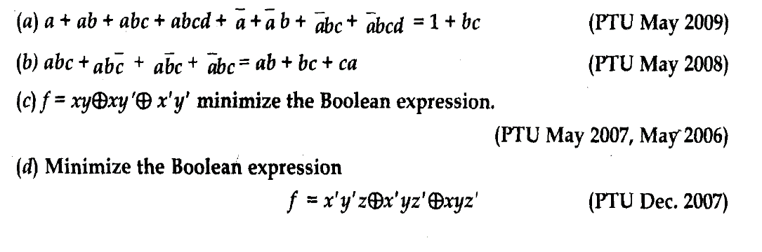
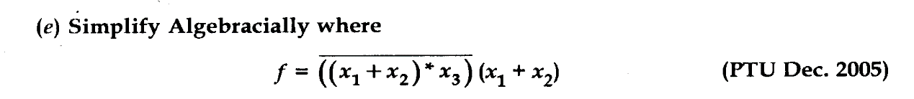

- Discuss various application of Boolean algebra.
- State the commutative Laws, associative Laws and absorption Law for Lattice.
- Define the following terms:
  - Complete Binary tree
  - Binary search tree
- What is minimum spanning tree of a graph? Write down Prim’s and Kruskal’s algorithms and execute them by taking a suitable example.
- What are the properties of minimum spanning tree?
- Using Dijkstras’s algorithm find the shortest path from s to t in the following graph:
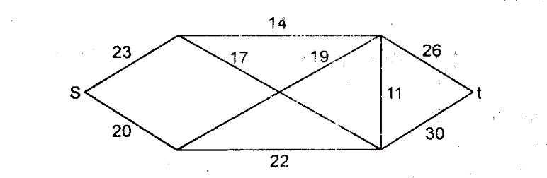

Tutorials- BTCS402 Discrete Structures

Tutorial Sheet-I
    - Discuss the symmetric diff. b/w two sets with symbols
    - Describe {3,5,7,9……77,79} in a set builder notation
    - What do you understand by fundamental product of sets A1,A2……An?
    - Given that AUB= AUC. Is it necessary that B=C?
    - Is a statement “a set with n elements has 2ⁿ subset when n =0”true?
    - What is a power set?
    - If A = {1,2,3,4,5,} find the cardinals no. the power set of A
    - If A= {1, 2, 3}, find P (A) =?
    - Differentiate b/w an ordered and unordered partition of a finite set.
    - Let {A1, A2……An} be a partition of set A. Let B be any non-empty sub set of A Prove that {A∩B} is a partition of (A∩B).

Tutorial Sheet-2
Topic: Permutations
- To find the no. of permutation of n diff. things taken r at a time.
- No. of permutation of n things taken all at a time is n!.
- E,R,S occur together (2) no two of the letters E,R,S occur together?
- You have to arrange n books on a shelf so that 2 particular books shall not be together; find no. of ways we can arrange?
- Find how many arrangements can be made with the letters of the word ‘MATHEMATICS’? In how many of them vowels occur together?
- In how many ways can 5 boys and 5 girls be seated at a round table, so that no two girls sit together?
- How many subsets of {1, 2, ---------- 10} contain at least 7 elements?
- If seven positive integers are chosen two of them will have same remainder, when divided by 6?
- Find the least no. of cables required to connect 100 computers to 20 printers to guarantee that 20 computers can directly access 20 diff. printer’s .justify your answers.
- Find the no.of a subset of a S containing n elements.
- A set contains (2n+1) elements. If the no. of subset of this set which contains almost n elements is 8192, find n?
- Suppose that there are n-people is in a room. n≥ 1and that they all share hands with one another, Prove that n(n-1)/2 hands share will occur?

Tutorial Sheet-3
Topic: Ring Theory
- Explain Rings and sub rings.
- Integral domain.
- Skew Field.
- Prove that every field is an integral domain.
- Prove that finite integral domain is field.
- Ring isomorphism and group isomorphism.
- Quotient rings.
- Euclidean domain.
- Show that relation of being associates is an equilance relation in ring R.
- Explain ideals.
- Explain proper and improper.
- Every ideal S ring of a ring R is a subring of R.
- Every subring S of a ring R is not an ideal.
- If R be a ring such that x²=x, prove that x+x=0 and x+y=0 then x=y.

PTU Syllabus-BTCS 403 Computer Networks-I

L T P
3 1 4

Objective/s and Expected Outcome: This course provides knowledge about computer network related hardware and software using a layered architecture.

PART-A

1. Introduction to Computer Networks:
Data Communication System and its components, Data Flow, Computer network and its goals, Types of computer networks: LAN, MAN, WAN, Wireless and wired networks, broadcast and point to point networks, Network topologies, Network software: concept of layers, protocols, interfaces and services, ISO-OSI reference model, TCP/IP reference model. [7]

2. Physical Layer:
Concept of Analog & Digital Signal, Bandwidth, Transmission Impairments: Attenuation, Distortion, Noise, Data rate limits : Nyquist formula, Shannon Formula, Multiplexing : Frequency Division, Time Division, Wavelength Division, Introduction to Transmission Media : Twisted pair, Coaxial cable, Fiber optics, Wireless transmission (radio, microwave, infrared), Switching: Circuit Switching, Message
Switching ,Packet Switching & their comparisons. [6]

3. Data Link Layer:
Design issues, Framing, Error detection and correction codes: checksum, CRC, hamming code, Data link protocols for noisy and noiseless channels, Sliding Window Protocols: Stop & Wait ARQ, Go-back-N ARQ, Selective repeat ARQ, Data link protocols: HDLC and PPP. [6]

4. Medium Access Sub-Layer:
Static and dynamic channel allocation, Random Access: ALOHA, CSMA protocols, Controlled Access: Polling, Token Passing, IEEE 802.3 frame format, Ethernet cabling, Manchester encoding, collision detection in 802.3, Binary exponential back off algorithm. [6]

PART-B

5. Network Layer:
Design issues, IPv4 classful and classless addressing, subnetting, Routing algorithms: distance vector and link state routing, Congestion control: Principles of Congestion Control, Congestion prevention policies, Leaky bucket and token bucket algorithms [6]

6. Transport Layer:
Elements of transport protocols: addressing, connection establishment and release, flow control and buffering, multiplexing and de-multiplexing, crash recovery, introduction to TCP/UDP protocols and their comparison. [3]

7. Application Layer:
World Wide Web (WWW), Domain Name System (DNS), E-mail, File Transfer Protocol (FTP),
Introduction to Network security [2]

Suggested Readings/ Books:
1. Computer Networks, 4th Edition, Pearson Education by Andrew S. Tanenbaum
2. Data Communication & Networking, 4th Edition, Tata McGraw Hill. By Behrouz A. Forouzan.
3. Computer Networking, 3rd Edition, Pearson Education by James F. Kurose and Keith W. Ross
4. Internetworking with TCP/IP, Volume-I, Prentice Hall, India by Douglas E. Comer.

Assignments-BTCS 403 Computer Networks-I

Assignment I
- Differentiate between LAN and MAN?
- Name various operations of Physical layer?
- Define the term: network topology and name its various types?
- Describe in brief the Architecture of TCP/IP model?
- What do you understand by term protocol?

Assignment 2
- Explain analog and digital signals?
- Explain various transmission impairments?
- Explain transmission media in detail?
- Explain the functioning ofSliding Window protocol?
- Explain error correction and detection methods in detail?

Assignment 3
- Name various operations ofData link layer?
- What do youmean bypacket switched network?
- What is flow control?
- What do youmean byNetwork reliability?
- Define the term congestion?
- Describe indetail the principle of CSMA/CD and Token ring protocol?
- What is the use of modulation?
- Explain indetail the design issues ofTransport layer protocols?

Assignment 4
- Explain indetail the different fields of IP header format?
- Write short notes on
  - Routing Algorithms.
  - Channel allocation.
  - IP addressing
- Explain indetail the design issues ofTransport layer protocols.
- Differentiate between E-mail and DNS services.
- Discuss in brief the various issues related to Network Security.
- Describe in brief the terms: FDM, WDM and TDM.

Tutorials- BTCS 403 Computer Networks-I

Tutorial No. 1
- Define Protocol architecture.
- What is a Protocol?
- What do you mean by standards?
- Name any four standards creation committees.
- Discuss simple protocol architecture?
- What are the main communication agents?
- Explain the Three layer model briefly.
- Define service access points?
- What is interface data unit (IDU)?
- Define service data unit (SDU).
- Define IC! (Interface control Unit).
- What is PDU (Protocol Data Unit)?
- What are the Merits and demerits of Os! Reference model?
- Write a short note on LAN.
- Write a short note on WANs.
- Define Internet?
- Write a short note on intranet.
- What is Extranet?
- Name any five standard creation committees
- Describe connection-oriented and connectionless services.
- Discuss the communication systems.
- Explain the OSI Reference model.
- Write down the Basic principles of OSI model.
- What is Sliding Window Protocol?
- What are the various networking devices?
- Explain TCP/IP Protocol.
- Write a short note on Ethernet.

Tutorial No. 2
Q. 1. What is an Error?
Q. 2. Define Error Control.
Q. 3. What are three types of redundancy checks used in data communication?
Q. 4. How can the simple parity bit detect a damaged data unit?
Q. 5. What is the difference between even parity and odd parity?
Q. 6. Define code world?
Q. 7. Define Code rate?
Q. 8. Define code efficiency?.
Q. 9. What are the disadvantages of coding?
Q. 10. Suppose the sender wants the word “HELLO”. In ASCII the five characters are coded as:
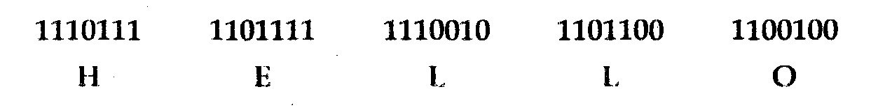
What will be the combination of actual bits to send?
Q. 11. How the receiver will detect that there is an error in:
Q. 12. Suppose the word HELLO is corrupted during transmission?
How receiver will check it out?\
Q. 13. Explain about error correction.
Q. 14. What is check sum?
Q. 15. Discuss the two dimensional parity check and the types of errors it can and cannot detect.
Q. 16. What are the different types of error?
Or
How a single bit error does differ from a burst error?
Q. 17. What is Error detection?
Q. 18. Discuss the concept of redundancy in error detection.
Q.19. Explain any one Mechanism used for error detection?
Or
What is the Parity check Method of Error detection?
Q. 20. Explain CRC method of Error Detection?
Q.21. How is the check sum method of error detection take place?
Q. 23. What is hamming code of Error Correction? How it calculate, the redundancy?
OR
Explain any one method used for error correction.
Q. 24. What are various error correction codes?

Tutorial No. 3
Q. 1. Define multiplexing.
Q. 2. State the importance of multiplexing.
Q. 3. What are the types of multiplexing?
Q.4.What is FDM?
Q.5. Write a short note on WDM.
Q. 6. Define TDM.
Q. 7. Explain the two types of TDM implementation and how do they differ from each other
Q. 8. What is Bit Padding?.
Q.9. what is interleaving?
Q. 10. Is bit padding is technique for FDM or TDM? Is the framing bit used in FDM or TDM?
Q.11. Define the difference between switched arid leased lines.
Q. 12. What are switched communications networks?
Q. 13. Define the difference between FDM and TDM.
Q.14. what are the two types of switches used in circuit switching? Explain in detail.
Q.15. Define about the circuit switching with example
Q. 16. Discuss the basic phases used in the circuit switching Networks.
Q. 17. What is circuit switching explain its elements?
Q.18. what do you mean by blocking and non-blocking networks?
Q. 19. What is in channel signaling?
Q. 20. Describe the public telecommunications network and what is DDS?
Q. 21. Describe the DS hierarchy.
Q. 22. Write a short note on packet switching. Also, discuss its switching techniques?
Q. 23. Name the phases of virtual circuit identifier and what is VOFR?
Q. 25. Compare datagram and virtual circuits.
Q.26.Differentiate circuit switching and datagram packet switching.
Q. 27. Write down the advantages of packet switching over circuit switching.
Q. 28 Differentiate between message, circuit and packet switching.
Q. 30. Compare the mechanism of a space division to the mechanism of a time division switch.

Tutorial No 4
Q. 1. What is Transmission Media?
Q. 2. What is Guided Transmission Media?
Q. 3. What is Unguided Media?
Q. 4. How do guided differ from unguided media?
Q. 5. Name two types of guided and unguided media.
Q. 6. What is the form of the signal in twisted pair cable and co-axial cable? How does this differ from the signal in fiber-optic cable?
Q. 7. What is the connector used for twisted pair cable?
Q. 8. What do you understand by wireless transmission?
Q. 9. What are three ways for wireless data to be propagated?
Q. 10. What is ground propagation?
Q. 11. What is the purpose of cladding in an optical fiber?
Q. 12. What is the connector used to connect devices through co-axial cable?
Q. 13. Define Shannon capacity and what is it a functions of it?
Q. 14. What is the NYQUIST Bandwidth?
Q. 15. Give the mathematical representation for the theoretical maximum capacity of a channel.
Q. 17. Define the difference between synchronous and asynchronous transmission.
Q. 18. Why twisted pair cables are twisted together?
Q. 19. What is the connector used to connect fiber optic?
Q. 20. What is the difference between the omnidirectional and unidirectional? And give example for each.
Q. 21. What are the applications of Radio wave?
Q. 22. What are the applications of micro wave?
Q. 23. What is sky propagation?
Q. 24. What is line-of-sight propagation?
Q. 25. What is IrDA port?
Q. 26.Difference between error control and flow control.
Q. 27. Write a short note on twisted pair and what are the various standards for twisted pair cable?
Q. 28. What are various connectors used in
Q. 29. What is difference between twisted pair, co-axial cable and fiber optics?
Q. 30. What is Radio wave transmission system?
Q. 31. What are the advantages and disadvantages of optical fibers?

Tutorial No 5
Q. 1. Explain the data transmission concept?
Q. 2. Explain the term Analog data transmission.
Q. 3. What is the frequency range for audio signal?
Q. 4. What is a sine wave?
Q. 5. What are the characteristics of sine wave?
Q. 6. What is digital data transmission?
Q. 7. What is digital signal?
Q. 8. What is Analog signal?
Q. 9. What is data rate?
Q. 10. What is channel?
Q. 11. What is Bandwidth?
Q. 12. What is baud rate?
Q. 13. Explain the terms bit rate and bit interval?
Q. 14. What is Periodic and Aperiodic Signals?
Q. 15. What is frequency spectrum?
Q. 16. Express a period of 100 ms in micro seconds and express the corresponding frequency in kilohertz.
Q. 17. What are the units of period and frequency?
Q. 18. A signal has a bandwidth of 20Hz. The highest frequency is 60 Hz. What is the lowest frequency?
Q. 19. What is the term “Computer Networks”?
Q. 20. Write disadvantages of analog signals?
Q. 21. What are various communication channel modes?
Q. 22. What are various types of communication / Transmission?
Q. 23. What is serial and parallel transmission?
Q. 24. Is there any method available that can help us to compute how fast we can send data over a channel?
Q. 25. What is Analog signal and what are the parameters of Analog signal?
Q.26. what are the measurements available in the data communication?
Q. 27. For the following frequencies, calculate the corresponding periods Write the result in seconds, milli seconds, micro seconds and Nano seconds, Pico second (24 Hz, 8 MHz).
Q. 28. If a bit rate of a signal is 100 bps, how many bits can be sent in 5 s? How many bits in 15 s? How many bits in 100 ms?
Q. 29. Difference between analog and digital data transmission ?And which is the best way of transmission?
Q. 30. Explain different NJW Architecture?
Q. 31. What are transmission impairments? Explain all of them?
PTU Syllabus-BTCS404 -Microprocessors and Assembly Language Programming
L T P
3 1 2

PART-A

1. Introduction: Introduction to Microprocessors, history, classification, recent microprocessors. [5]

2. Microprocessor Architecture: 8085 microprocessor Architecture. Bus structure, I/O, Memory & System buses, concept of address Bus, Data Bus & Control Bus, Synchronous & Asynchronous buses. Instruction execution sequence & Data Flow, Instruction cycle.[5]

3. I/O memory interface: Data transfer modes: Programmable, interrupt initiated and DMA. Serial & parallel interface, Detail study of 8251 I/O Processor & 8255 programmable peripheral interfaces.[6]

PART-B
4. Instruction set & Assembly Languages Programming: Introduction, instruction & data formats, addressing modes, status flags, 8085 instructions, Data transfer operations, Arithmetic operations, Logical operations, Branch operations. [7]

5. Case structure & Microprocessor application: Interfacing of keyboards and seven segment LED display, Microprocessor controlled temperature system (MCTS), Study of traffic light system, stepper motor controller, Microprocessor based microcomputers. [8]

6. Basic architecture of higher order microprocessors: Basic introduction to 8086 family, Motorola 68000, Pentium processors. [5]

Suggested Readings/ Books:

1. 8085 Microprocessor by Ramesh Gaonkar, PHI Publications.
2. Daniel Tabak,Advanced Microprocessors, McGraw- Hill, Inc., Second Edition 1995.
3. Douglas V. Hall, Microprocessors and Interfacing: Programming and Hardware, Tata McGraw Hill Edition,
1986.
4. Charles M.Gilmore, Microprocessors: Principles and Applications, McGraw Hill.

Assignments- BTCS 404 -Microprocessors and Assembly Language Programming

Assignment - 1
      - Explain the function of each component of a computer.
      - What is a Microprocessor? What is the difference between a Microprocessor & CPU?
      - Classify Various types of microprocessors
      - Draw and Explain microprocessor 8085 microprocessor Architecture

Assignment - 2
- Explain Instruction Cycle in Detail
- Explain various types of buses in Microprocessor 8085.
- Explain the memory structure for Microprocessor 8085
- Why are the program counter and the stack pointer 16-bit registers?

Assignment - 3
- Explain various addressing modes of 8085.
- Differentiate the types of instructions based on their memory size
- Describe the concept of DMA
- Explain architecture of DMA controller?

Assignment – 4
- Discuss Serial and parallel communication in Microprocessor 8085
- Discuss interfacing of keyboard with microprocessor 8085
- Discuss 8251 in detail.
- Explain interfacing 8255 with Microprocessor 8085?

Assignment – 5
- Discuss architecture of microprocessor 8086
- Briefly give the introduction to Intel Pentium series processors
- What are the various types of interrupts

Tutorials- BTCS 404 -Microprocessors and Assembly Language Programming

Tutorial Sheet-I
1. What is Microprocessor? Give the power supply & clock frequency of 8085
2. What are the functions of an accumulator?
3. List the 16 – bit registers of 8085 microprocessor
4. List few applications of microprocessor-based system
5. List the allowed register pairs of 8085
6. Mention the purpose of SID and SOD lines
7. What is an Opcode?
Tutorial Sheet-2

- What is the function of IO/M signal in the 8085?
- What is meant by interrupt?
- Explain priority interrupts of 8085.
- What is a microcomputer?
- What is an Operand?
- How many operations are there in the instruction set of 8085?
- List out the five categories of the 8085 instructions. Give examples of the instructions for each group?
Tutorial Sheet-3

- Explain the difference between a JMP instruction and CALL instruction

- Explain the purpose of the I/O instructions IN and OUT.

- What is the difference between the shifts and rotate instructions?

- Explain LDA, STA and DAA instructions
- What is the difference between INR & INX instructions?
- Write about CALL and RET instructions in 8085?

Tutorial Sheet-4
- Write about the features of DMA
- Write down the function of OBF in 8255
- List the features of 8279
- What is meant by polling?
- What is meant by interrupt?
- Explain priority interrupts of 8085.
- What is a microcomputer?

Tutorial Sheet-5

- What is the signal classification of 8085?
- What are operations performed on data in 8085
- Steps involved fetching a byte in 8085
- What is a T-state?
- Explain the signals HOLD, READY and SID
- Why do we use XRA A INSTRUCTION?
- Compare CALL and PUSH instruction?
Tutorial Sheet-6

- What is the use of ALE?
- Steps involved fetching a byte in 8085
- Explain priority interrupts of 8085
- What is the use of bi-directional buffers?
- How many address lines in a 4096 x 8 EPROM CHIP?
- Define Flags

PTU Syllabus- BTCS 405 System Programming

L T P
312
Objective/s and Expected Outcome: This course provides knowledge to design various system
Programs.

1. Introduction: Introduction to system programming and different types of system programs - editors, assemblers, macro processors, compilers, linkers, loader, debuggers. [2]

2. Assemblers: Description of single pass and two pass assemblers, use of data structures like OPTAB and SYMTAB, etc. [9]

3. Macroprocessors: Description of macros, macro expansion, conditional and recursive macro
Expansion. [5]

4. Compilers: Various phases of compiler - lexical, syntax and semantic analysis, intermediate code generation, code optimization techniques, code generation, Casestudy: LEX and YACC. [9]

5. Linkers and Loaders: Concept of linking, different linking schemes, concept of loading and various loading schemes. [5]

6. Editors: Line editor, full screen editor and multi window editor, Case study MS-Word, DOS Editor and vi editor. [4]

Debuggers: Description of various debugging techniques. [2]

Suggested Readings/ Books:
1. Donovan J.J., Systems Programming, New York, Mc-Graw Hill, 1972.
2. Dhamdhere, D.M., Introduction to Systems Software, Tata Mc-Graw Hill, 1996.
3. Aho A.V. and J.D. Ullman Principles of compiler Design Addison Wesley/ Narosa 1985.7.

Assignments BTCS 405 System Programming

Assignment – 1
Introduction to System Programming

- What is system programming?
- Briefly explain different types of system programs.
- What is the difference between compiler and interpreter?
- Describe the machine structures in detail.
- Explain Machine languages and Assembly Languages.

Assignment – 2
Machine Structure, Assembler and Macro Processors

- What do you mean by assembler?
- Explain machine structure 360 and 370.
- Explain the working of single pass assembler. And two pass assembler. Explain the differences between two.
- Explain the working of OPTAB and symbol table in detail.
- Explain macro and macro expansion in detail.

Assignment – 3
Compiler

- Explain the various phases of Compilers?
- What are various code optimization techniques?
- What Difference between Lexical and Syntax Phase?
- Explain the storage assignment phase.
- Explain the differences between LEX and YACC.

Assignment – 4
Linking and Loading

- What is function of linker and loader?
- Briefly explain various linking schemes.
- Briefly explain various loading schemes.
- What is the difference between relocating loader and direct linking loader?
- How to design an absolute loader.

Assignment – 5
Editor and Debugging

- Explain different types of editors.
- Explain the difference between line editor and full screen editor
- Briefly explain DOS editor and vi editor.
- Explain debugging and debugging procedure.
- Name the various debugging techniques. Briefly explain them.

Tutorials-BTCS 405 System Programming

Tutorial Sheet-I

- Define term system programming.
- What is the difference between assembly language, high level language and machine language?
- Write the differences between linker and loader.
- Briefly explain the foundation of system programming.
- Explain the function of assembler and compiler.
- What is the difference between compiler and interpreter?
- What is subroutine? Explain the types of subroutines.
- What is the functioning of macro processor?
- Explain general machine structure.
- Explain the data format and instruction format for the system 360/370.

Tutorial Sheet-II

- What is the difference between pass and phase?
- List advantages of binding at load time and binding at compile time.
- What are the features required in assembly language to build a two-pass assembler?
- What are the different types of assemblers known to you?
- What is instruction counter?
- What is the need of assembler?
- What is the general design procedure for design of an assembler?
- Briefly explain first pass and second pass of an assembler
- Write the advantages of two pass over one pass assembler.
- Briefly explain OPTAB and SYMTAB

Tutorial Sheet-III

- Define the term macro.
- Define macro expansion.
- Write the differences between conditional and recursive macro expansion?
- What do you mean by symbol table?
- What are the various errors seen in compiler?
- What are compiler writing tools?
- What is code generation?
- What do you mean by literal table?
- What is lexical analysis?
- Define syntax analysis.
- Explain intermediate code generation
- What is translator?
- What is the requirement of optimization?
- Name the different types of compiler.
- Describe system and application programming.

Tutorial Sheet-IV

- What is loading of a program?
- Why is necessary to relocate a program in memory?
- Differentiate between rellocatable and self-relocating programs.
- In a two pass direct linking loader what is function of pass1?
- Differentiate between static relocation and dynamic relocation.
- What is absolute loader?
- What are the advantages of direct linking loader?
- What is the role of linker in program execution?
- Explain the differences between linker and loader.
- What is linking? What is the use of linking?

Tutorial Sheet-V

- What is VI editor?
- Differentiate between full screen editor and multi window editor.
- What are the salient features of DOS editor?
- What is text editor? Describe various types of text editors and their utility.
- Write note on debuggers.
- Write short note on line editor.
- Differentiate breakpoint method and single step control method of debugging.
- What is bug?
- List the various software tools used for debugging.
- Explain various debugging techniques.

PTU Syllabus-BTCS 406 Operating System Lab
L T P
0 02

- Installation Process of various operating systems

- Virtualization, Installation of Virtual Machine Software and installation of Operating System on Virtual Machine

- Commands for files & directories: cd, ls, cp, md, rm, mkdir, rmdir. Creating and viewing files using cat. File comparisons. Disk related commands: checking disk free spaces. Processes in linux, connecting processes with pipes, background processing, managing multiple processes. Manual help. Background process: changing process priority, scheduling of processes at command, batch commands, kill, ps, who, sleep. Printing commands, grep, fgrep, find, sort, cal, banner, touch, file. File related commands ws, sat, cut, grep.

- Shell Programming: Basic of shell programming, various types of shell, Shell Programming in bash, conditional & looping statement, case statements, parameter passing and arguments, shell variables, shell keywords, creating shell programs for automate system tasks, report printing.

BT CS 406 Operating Systems Lab Work Flow

List of Experiments

Exp. No. | Experiment Description
1 | Installation of Window 7, Window XP Operating System.
2 | Study ,Installation& usage of Virtual Machine Software for Virtualization.
3 | Installation of Linux/Unix Operating System through Virtual Machine.
4 | Study the Commands for files & Directories- cd, ls, cp md, rm, mkdir, rmdir
5 | Study of Files & Disk Related Commands, viewing files using cat , Processes & batch Commands - kill, ps, who, sleep in Unix/ Linux.
6 | Study of Printing commands, grep, fgrep, find, sort, cal, banner, touch & File related commands ws, sat, cut, grep
7 | Basics of Shell programming-conditional & looping statements, parameter passing & report printing

All the experiments of Operating System will be performed on Red Hat Linux 5. Work Flow will be as follows:
- Introduction about the experiment to be performed.
- Hardware Software Requirements.
- Tools Required.
- Experiment working/Operation or Command detail with examples.
- Results of the Command/Query will be noted down by the students and will be written in practical File.
- At the end of every experiment, students will be given some questions for practice.

Tools Required:
- Red Hat Linux 5:
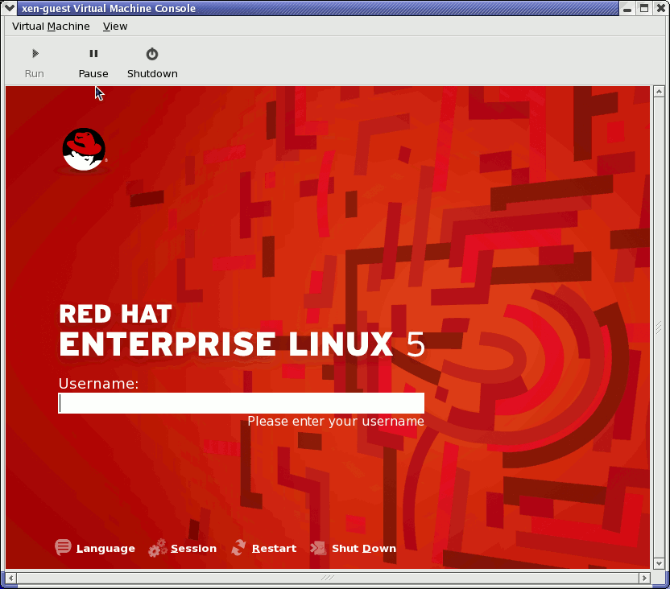

PTU Syllabus-BTCS 407 Computer Networks-I Lab
L T P
0 0 4

- Write specifications of latest desktops and laptops.

- Familiarization with Networking Components and devices: LAN Adapters, Hubs, Switches, Routers etc.

- Familiarization with Transmission media and Tools: Co-axial cable, UTP Cable, Crimping Tool, Connectors etc.

- Preparing straight and cross cables.

- Study of various LAN topologies and their creation using network devices, cables and computers.

- Configuration of TCP/IP Protocols in Windows and Linux.

- Implementation of file and printer sharing.

- Designing and implementing Class A, B, C Networks

- Subnet planning and its implementation

- Installation of ftp server and client.

BTCS 407 Computer Networks-I Lab
Work Flow

List of Experiments:

- Write specifications of latest desktops and laptops.

- Familiarization with Networking Components and devices: LAN Adapters, Hubs, Switches, Routers etc.

- Familiarization with Transmission media and Tools: Co-axial cable, UTP Cable, Crimping Tool, Connectors etc.

- Preparing straight and cross cables.

- Study of various LAN topologies and their creation using network devices, cables and computers.

- Configuration of TCP/IP Protocols in Windows and Linux.

- Implementation of file and printer sharing.

- Designing and implementing Class A, B, C Networks

- Subnet planning and its implementation

- Installation of ftp server and client.

Mostly experiments of CN-I Lab will be performed using CISCO PACKET TRACER 6.0.1(simulation tool) Work Flow will be as follows:

  - Introduction about the experiment to be performed.
  - Tools required.
  - Software and Hardware Requirements.
  - Case study of the experiments with example.
  - Performing the experiments using Tools.

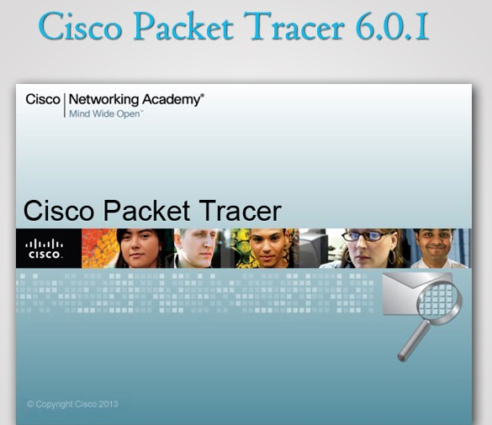

PTU Syllabus-BTCS408 Microprocessor and Assembly Language Programming Lab

L T P
0 02

- Introduction to 8085 kit.

- Addition of two 8 bit numbers, sum 8 bit.

- Subtraction of two 8 bit numbers.

- Find 1’s complement of 8 bit number.

- Find 2’s complement of 8 bit number.

- Shift an 8 bit no. by one bit.

- Find Largest of two 8 bit numbers.

- Find Largest among an array of ten numbers (8 bit).

- Sum of series of 8 bit numbers.

- Introduction to 8086 kit.

- Addition of two 16 bit numbers, sum 16 bit.

- Subtraction of two 16 bit numbers.

- Find 1’s complement of 16 bit number.

- Find 2’s complement of 16 bit number.

References:

Microprocessor by B. Ram, DhanpatRai Publications.

BTCS408 Microprocessor and Assembly Language Programming Lab Work Flow

List of Experiments:

- Introduction to 8085 kit.

- Addition of two 8 bit numbers, sum 8 bit.

- Subtraction of two 8 bit numbers.

- Find 1’s complement of 8 bit number.

- Find 2’s complement of 8 bit number.

- Shift an 8 bit no. by one bit.

- Find Largest of two 8 bit numbers.

- Find Largest among an array of ten numbers (8 bit).

- Sum of series of 8 bit numbers.

- Introduction to 8086 kit.

- Addition of two 16 bit numbers, sum 16 bit.

- Subtraction of two 16 bit numbers.

- Find 1’s complement of 16 bit number.

- Find 2’s complement of 16 bit number.

8085 MICROPROCESSOR KIT
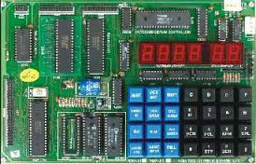
In the microprocessor lab a microprocessor kit will be used which is shown in above diagram. Students have to perform all the experiments of microprocessor lab on this kit. Assembly language code for various experiments will be written into kit from kit manual and according results will be on the screen.

PTU Syllabus-BTCS 409 System Programming Lab

L T P
0 0 2

- Create a menu driven interface for

  - Displaying contents of a file page wise

  - Counting vowels, characters, and lines in a file.

  - Copying a file

- Write a program to check balance parenthesis of a given program. Also generate the error report.

- Write a program to create symbol table for a given assembly language program.

- Write a program to create symbol table for a given high-level language program.

- Implementation of single pass assembler on a limited set of instructions.

- Exploring various features of debug command.

- Use of LAX and YACC tools.

BTCS 409 System Programming Lab

List of Experiments

1. Create a menu driven interface for
a) Displaying contents of a file page wise
b) Counting vowels, characters, and lines in a file.
c) Copying a file
2. Write a program to check balance parenthesis of a given program. Also generate the error report.
3. Write a program to create symbol table for a given assembly language program.
4. Write a program to create symbol table for a given high-level language program.
5. Implementation of single pass assembler on a limited set of instructions.
6. Exploring various features of debug command.
7. Use of LAX and YACC tools.

Work Flow of SP LAB

Mostly experiments of SP will be performed using Turbo C++, LEX and YACC tools Work Flow will be as follows:
  - Introduction about the experiment to be performed.
  - Tools required.
  - Software and Hardware Requirements.
  - Case study of the experiments with example.
  - Performing the experiments using Tools.
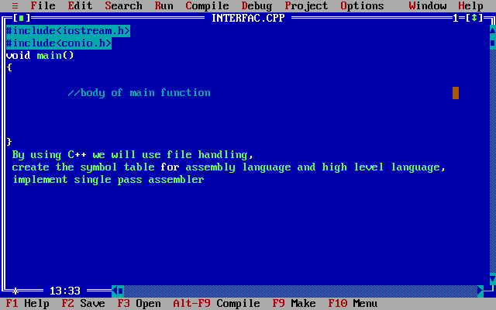

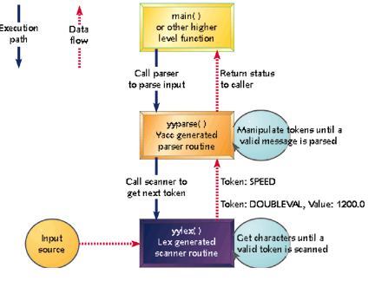

DEPARTMENT TEACHERS

S.no | Name of Teacher | Subject | Contact No | Email id
1 | Er. PuneetGarg | Operating System | 8437700327 | asrahodcse@gmail.com
2 | Er. RajnishKansal | Computer Networks I | 9876063764 | asra.cse.rajnish@gmail.com
3 | Er. Jasmeen | System Programming | 9815733473 | asracsejasmeenjaura@gmail.com
4 | Er. VivekBawa | MP & ALP | 9473874443 | asraecevivek@gmail.com
5 | Dimple Chawla | Mathematics -III | 9988640330 | Dimplechawla23@yahoo.com
6 | Er. Inderjeet Singh | - | 8699100160 | asracseinder@gmail.com
7 | Er SouravGarg | - | 9915848810 | asracsesrv@gmail.com
8 | Er. Manish Mittal | - | 8699990597 | asratpo@gmail.com
9 | Er SimranDhindsa | - | 9780108904 | Asra.cse.simran@gmail.com
10 | Er Mohit Kumar | - | 9888103368 | asracsemk@gmail.com

